EXPERIMENT – 8
TITEL: APPLICATION APP USING BALSAMIQ
NAME :RAGHURAM
ROLL NO : 240701812
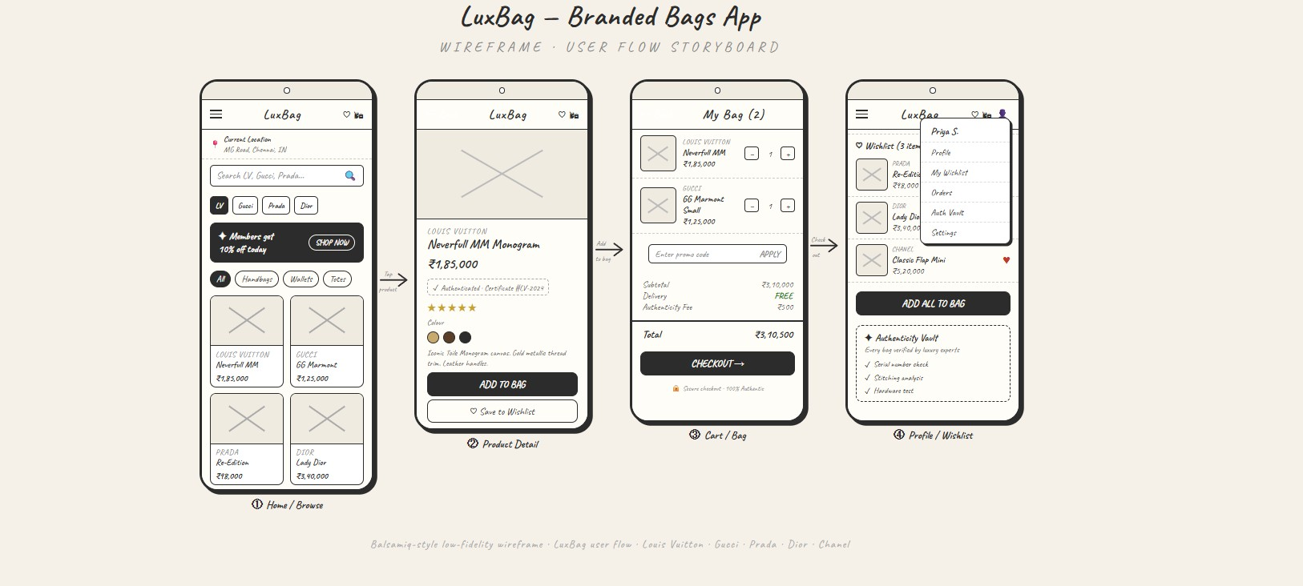
TITEL: APPLICATION APP USING BALSAMIQ

LuxBag - Branded Bags App Overview

- Summary

The LuxBag Mobile App provides users with a place to browse, search, and purchase luxury branded bags by some of the most popular luxury labels including Louis Vuitton, Gucci, Prada, Dior, and Chanel. This app is geared towards delivering a luxury shopping experience through an easy-to-use mobile application containing a wish list management tool, secure checkout, and product authenticity verification.

- Goals

The main goals of this application are:

To optimize the shopping experience for users when purchasing luxury bags via the mobile medium.
To provide users with a selection of curated luxury brands.
To build user trust through verification of product authenticity.
To improve the user experience through easy navigation and intuitive design.

- Intended Users

Fashion lovers
People who buy luxury products
Young professionals and adults
People who buy luxury brands online

- Application Features

  - Home / Browse Page

The initial page displays featured luxury bags, has a search bar to find products quickly, has category filters (all bags, handbags, wallets, totes), and has promotional banners (discounts).

  - Item Detail Page

Each item page has detailed product pages, displaying the price, rating, and colour choices. Users can select "add to bag" or "save to wish list".

  - Cart / Bag Page

This page shows products selected by the user with the ability to edit select quantity, enter promotional codes, and determine shipping cost. This page will also show subtotal, delivery cost, total, and has a checkout button.

  - User Profile / Wish List Page

Each user will have their profile where they can view items in their wish lists, and the ability to "add all" to their bag (assumes all items in their wish list) will have access to the user's order history, profiles and settings, etc.

Conclusion

LuxBag offers an organized, user-friendly experience that allows consumers to shop easily for their next luxury bag. The wireframe outlines the main features of the application as well as how users will navigate through it; therefore, with additional development and feature additions, this app has excellent potential to develop into a fully functioning e-commerce solution for high-end fashion products.

